**Broadband Performance Analysis for IPV4 and IPV6**

**1. Introduction**

We compared the performance between IPv4 and IPv6 based on the FCC broadband measurements data. Basically we explored the performance difference between IPv4 and IPv6 in four aspects of the datasets:

(1) Performance among carriers

(2) Performance among technologies

(3) Load-sensitivity between IPv4 and IPv6

**2. Performance of IPv4 and IPv6**

**2.1 Dataset**

For exploration of performance, we use the broadband dataset of IPv4 downloading, IPv4 uploading, IPv6 downloading and IPv6 uploading respectively during the first half year of 2018. We assume the data size within the time range could already be a good representative of the overall performance statistics of IPv4 and IPv6.

**2.2 Metrics**

Performance is defined as the ratio between bytes per second and the speed tier of the node. For load-sensitivity, the busy hours is defined as 5 – 10pm local time. Reduction is defined as (performance during non-busy time – performance during busy time) / (performance during non-busy time).

**2.3 Data Cleaning**

For performance comparison, first we removed failed tests which were not considered in analysis. As FCC mentioned, we also removed tests with greater than 6 result intervals because speed tests should have no more than 6 result intervals. After aforementioned steps, we had 790 nodes for download and 785 nodes for upload. Then we selected nodes which have valid for both download and upload and then the final number of nodes for analysis is 785.

**2.4 Experiment Results**

For comparison, we took mean of each node’s download and upload speed over 6 months and then calculated the ratio of IPv4 speed over IPv6 speed and subtract 1. In other words, if the speeds are same, the result should be zero.

**2.4.1 Performance Among Carriers**

1. **Download Performance Comparison Results**

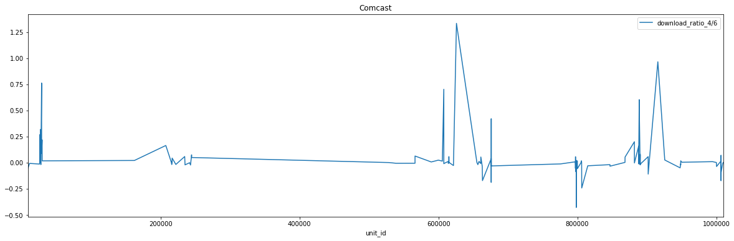

ISP: Comcast Count: 149 std: 0.18664 mean: 0.039406

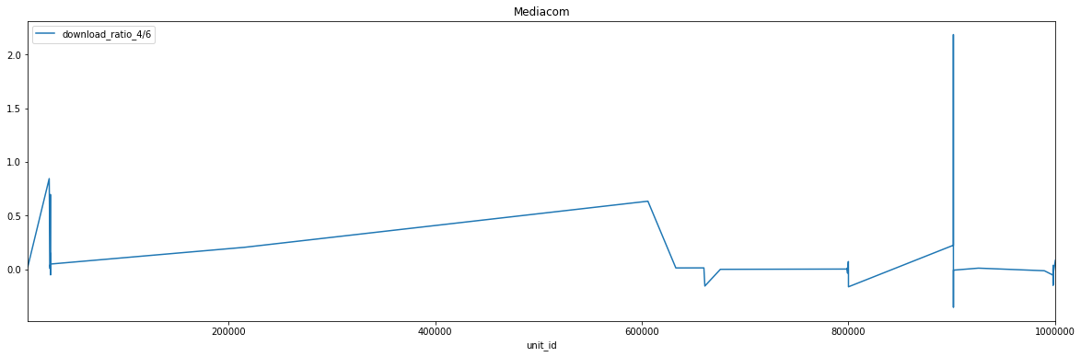

ISP: Mediacom Count: 46 std: 0.37206 mean: 0.092963

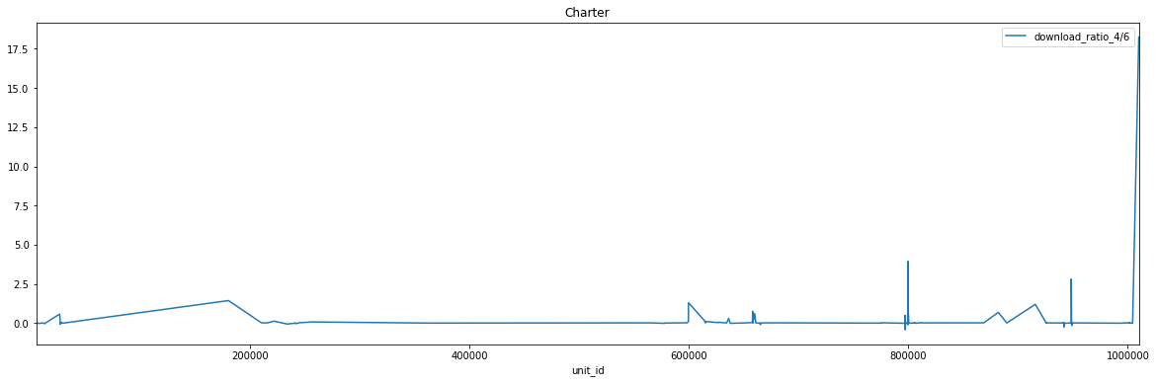

ISP: Charter Count: 129 std: 1.66153 mean: 0.256545

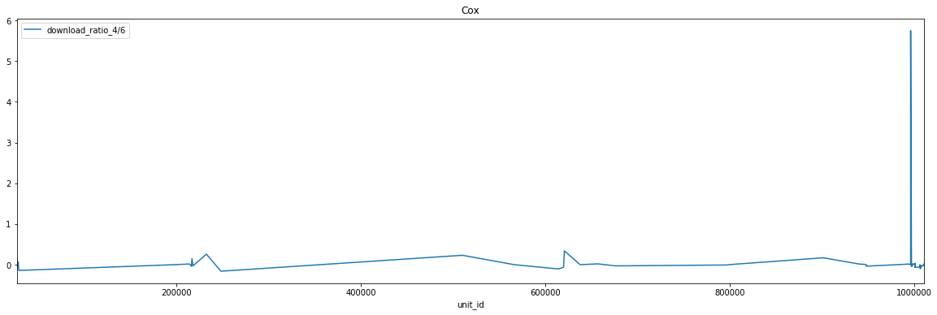

ISP: Cox Count: 62 std: 0.72850 mean: 0.098036

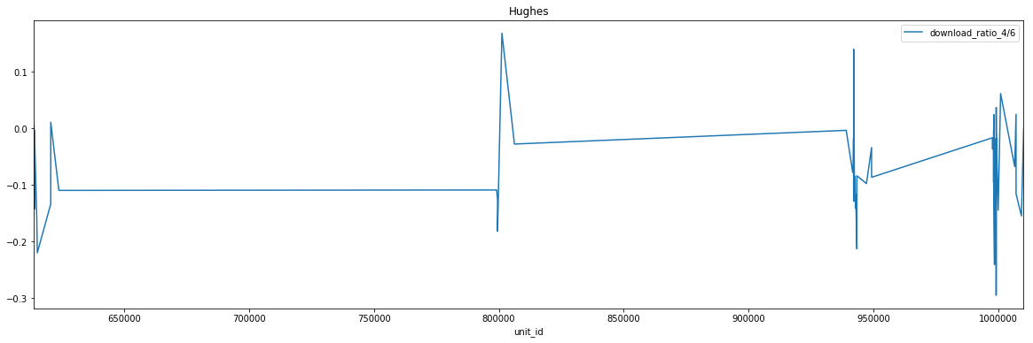

ISP: Hughes Count: 61 std: 0.08806 mean: -0.075393

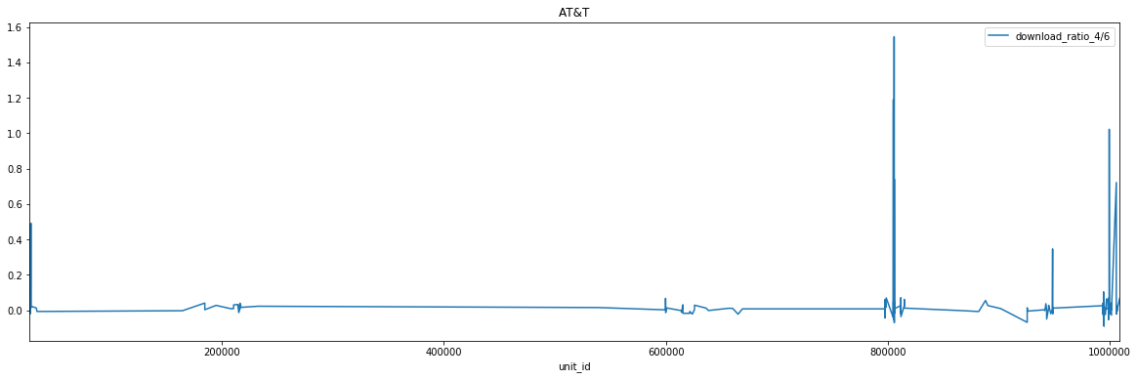

ISP: AT&T Count: 301 std: 0.15334 mean: 0.035691

1. **Upload Performance Comparison Results**

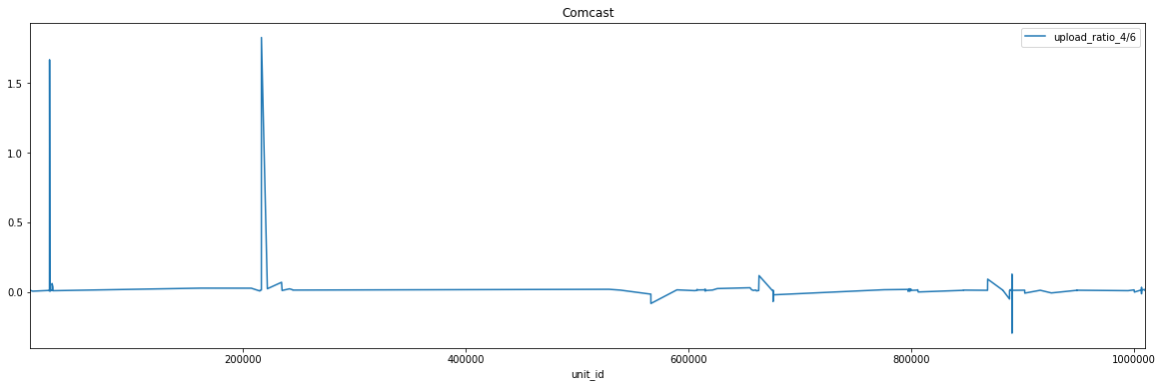

ISP: Comcast Count: 149 std: 0.20275 mean: 0.034103

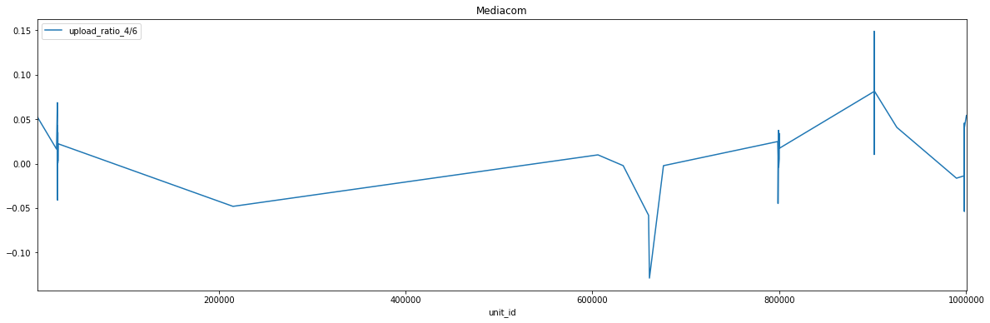

ISP: Mediacom Count: 46 std: 0.04513 mean: 0.014823

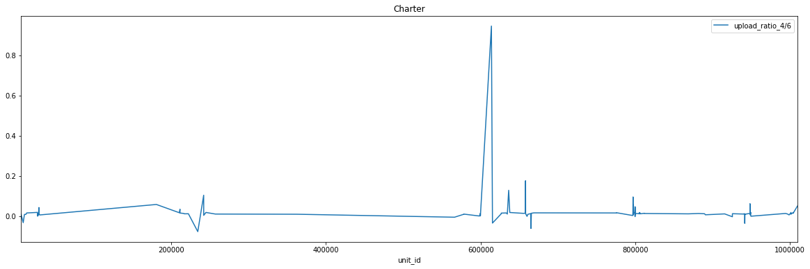

ISP: Charter Count: 129 std: 0.08584 mean: 0.021384

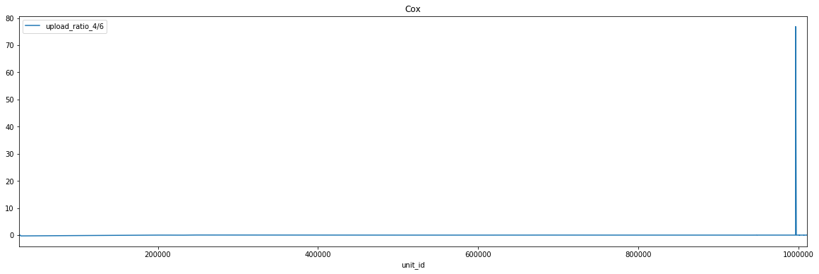

ISP: Cox Count: 62 std: 9.68419 mean: 1.246060

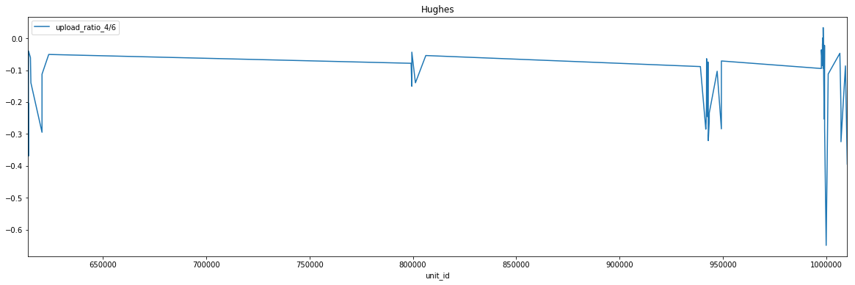

ISP: Hughes Count: 61 std: 0.12493 mean: -0.145131

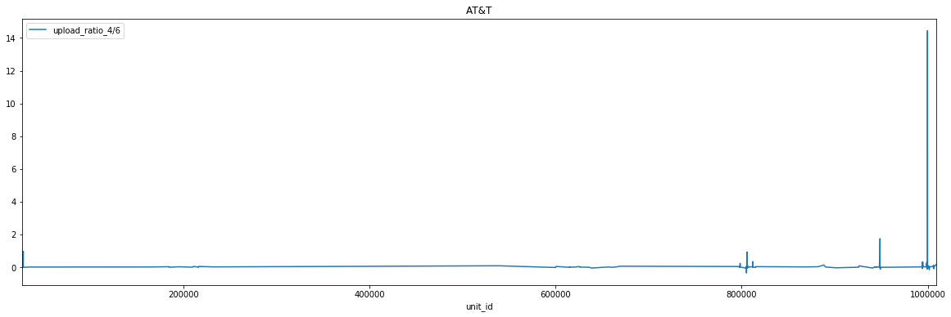

ISP: AT&T Count: 301 std: 0.84140 mean: 0.094167

Other ISP have too less nodes to be considered.

As shown in the graphs, most nodes have result that is close to zero except several significant bumps. However, most of the bumps are towards positive especially notable bumps which means IPv4 have better performance than IPv6 in this situation. Hughes is the only ISP who has negative mean for download and upload results.

**2.4.2 Performance among technologies**

1. **Download Performance Comparison Results**

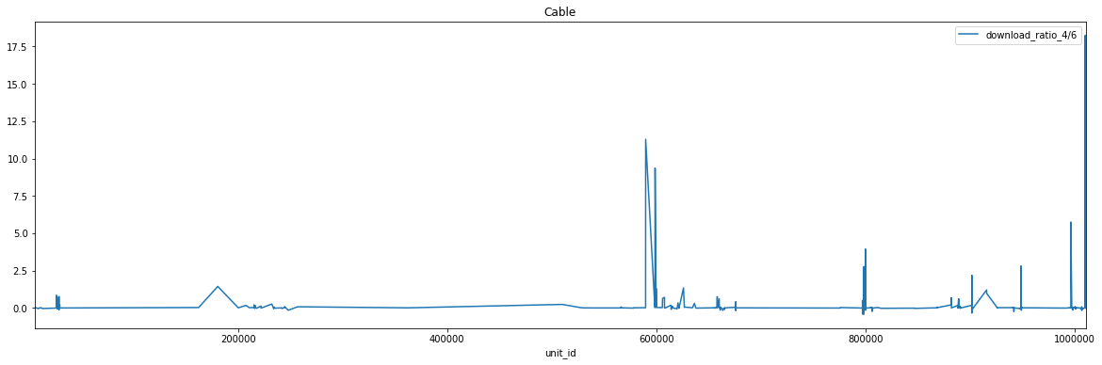

ISP: Cable Count: 391 std: 1.25907 mean: 0.188081

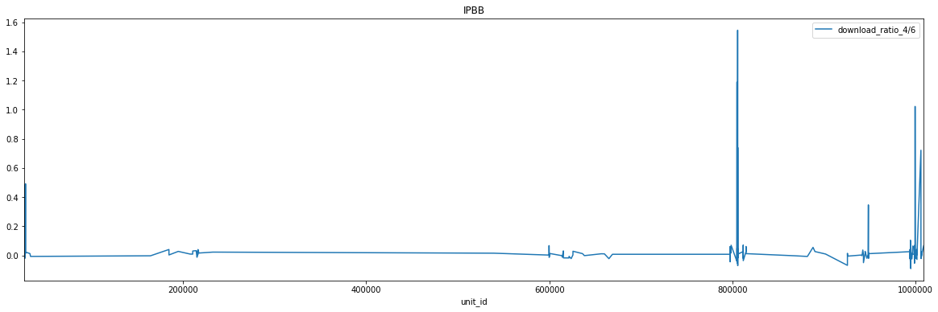

ISP: IPBB Count: 301 std: 0.153344 mean: 0.035691

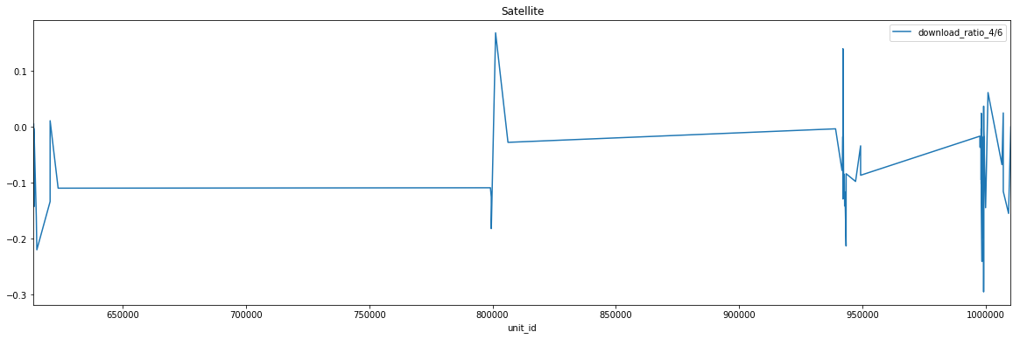

ISP: Satellite Count: 61 std: 0.08806 mean: -0.075393

1. **Upload Performance Comparison Results**

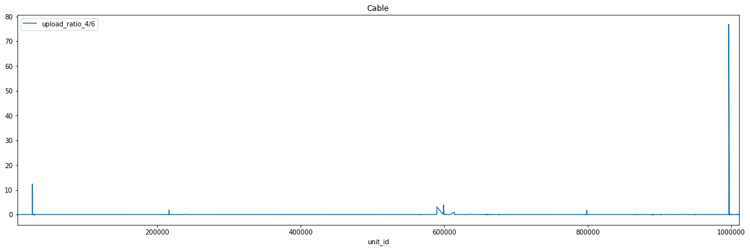

ISP: Cable Count: 391 std: 3.93943 mean: 0.273299

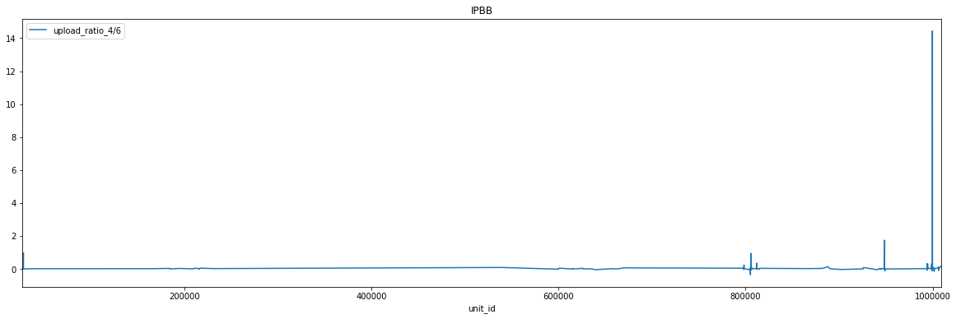

ISP: IPBB Count: 301 std: 0.84140 mean: 0.094167

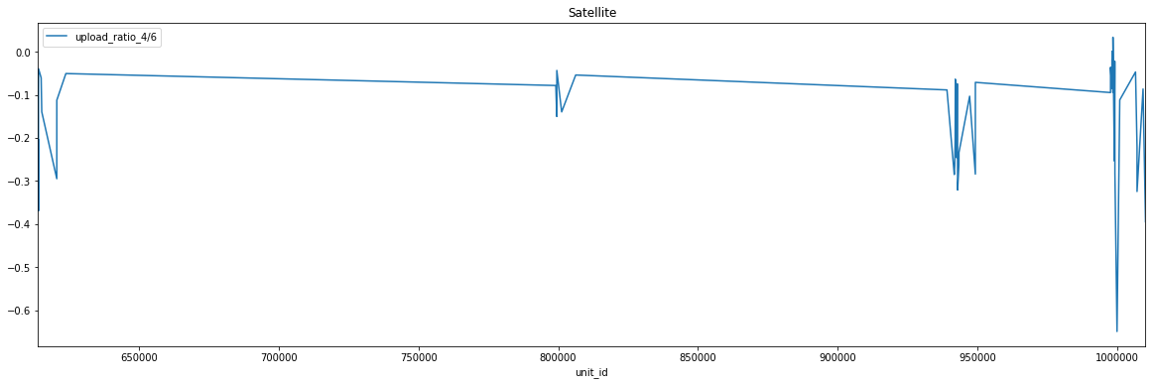

ISP: Satellite Count: 61 std: 0.12493 mean: -0.145131

The results are quite similar to results from 3.4.1. However, the bumps are much larger than before. Satellites is the only Technology who has negative mean for download and upload results.

**2.4.3 Load-sensitivity between IPv4 and IPv6**

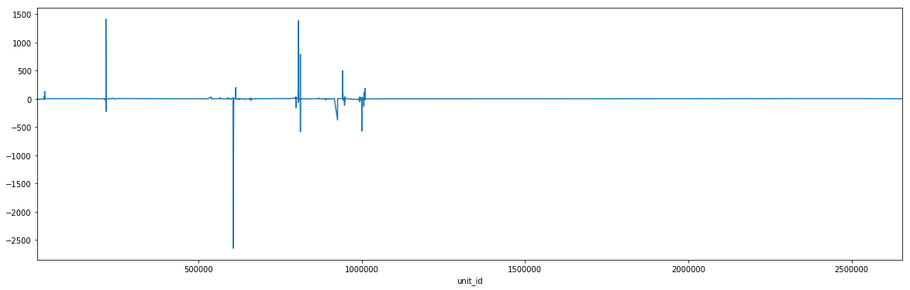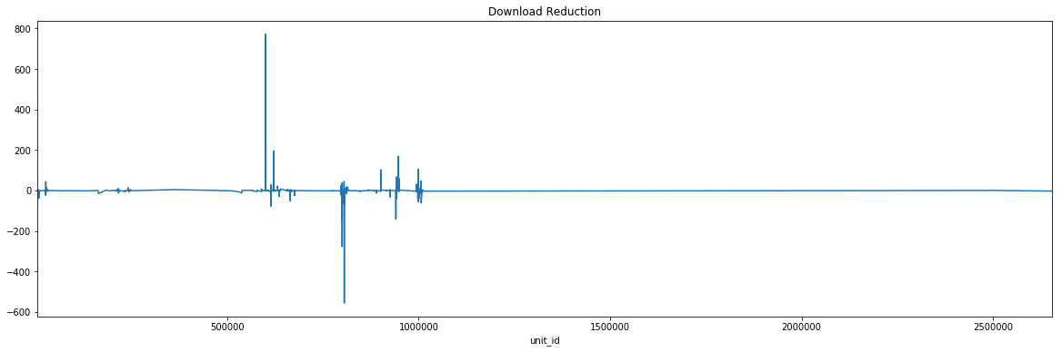

As shown in graphs, the ratio for reductions between IPv4 and IPv6 fluctuate remarkably but have no preferred direction.

**3. Conclusion**

Both performance comparisons show that IPv4 and IPv6 have similar performance for most of the nodes. However, most of the bumps especially significant ones represent that IPv4 is faster than IPv6 for that node. An educated guess may be IPv6 is unstable at certain time which lead to very high ratios. For load-sensitivity, no evidence suggests that IPv4 and IPv6 have notable difference.

**4. Future Work**

Since too few nodes for several carriers and technologies, the next step could be testing nodes for specific carriers and technologies to enlarge the sample size in order to perform analysis.

**5. Acknowledgements**

We would like to thank Professor Henning Schulzrinne at Columbia University for his support and instruction on this project.